**Galw Gofal has achieved British Standard ISO 9001:2008**

**for Quality Management Systems in June 2014**

**BACKGROUND**

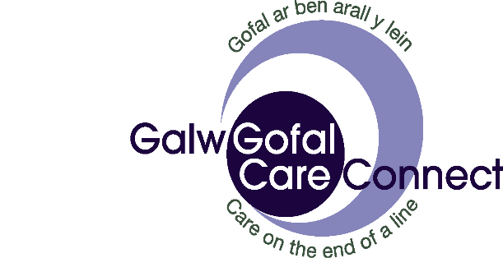Galw Gofal / Care Connect is a Regional Call Monitoring Service run in Partnership between Anglesey, Conwy, Flintshire and Gwynedd Council. The service is hosted by Conwy Council.

Three local authority call monitoring centres were merged into one single line managed regional service in 2011. This was to ensure a consistent and sustainable future proofed service across North Wales that was accredited to Telecare Services Association (TSA) and quality standards.

A Partnership Agreement was established to ensure that Galw Gofal would always strive to do the best it can for its commissioners in delivering their Telecare and customer services to the public.

Under the Partnership Agreement a Quality Assurance System needed to be in place to ensure that agreed standards of service are maintained. A Quality Assurance Framework was established.

**WHAT’S CHANGED?**

Galw Gofal refined its Quality Assurance Framework to meet the ISO 9001:2008 standard in 2014. The British Standard ISO 9001 is the world’s most popular quality management system standard. It covers how organisations should manage their activities and it concentrates on what organisations should do to make sure that their customers’ requirements are met consistently. ISO 9001 is a framework that puts robust structures in place to manage how everything is done.

The process involved an initial gap analysis assessment followed by a staged audit process to gain accreditation. Certification was awarded for three years in June 2014 and is subject to an annual external audit.

**WHAT DIFFERENCE HAS IT MADE?**

The Standard had provided a reporting framework for effective governance and accountability that ensures continuous improvement for the service. A ‘check and act’ approach via an internal audit, checking that processes and procedures are followed, that there is effective use of resources, that all corrective actions are identified and acted upon. The outcomes are communicated at all levels and customer satisfaction is measured.

Having the British Standard ISO 9001:2008 for Quality Management Systems demonstrates to current and prospective customers that Galw Gofal is a well organised and professional service.